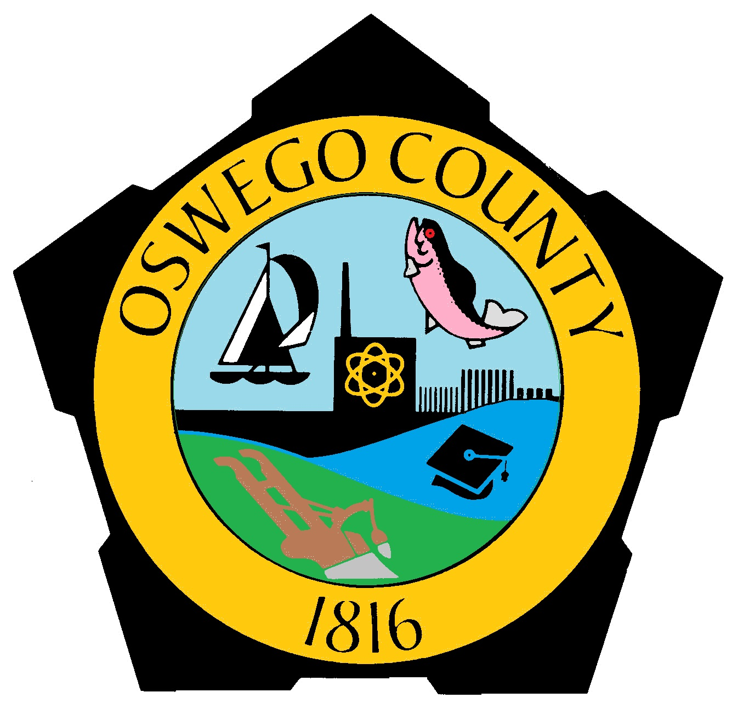
OSWEGO COUNTY LEGISLATURE

County Office Building ● 46 East Bridge Street ● Oswego, NY 13126
Phone 315-349-8230 Fax 315-349-8237

FOR IMMEDIATE RELEASE Sunday, March 15, 2020
State of Emergency declared–
CHAIRMAN ORDERS CLOSURE OF SCHOOLS IN OSWEGO COUNTY
OSWEGO COUNTY – Oswego County Legislature Chairman James Weatherup has ordered the closure of K-12 schools March 16 until April 14 to slow or reduce the potential spread of COVID-19 in Oswego County. Legislature Chairman Weatherup has declared a local State of Emergency, but stresses this action is being taken out of an abundance of caution.
“There is currently no confirmed case of COVID-19 in Oswego County,” Legislature Chairman Weatherup said. “Because both travel-related cases and community contact transmission has occurred within New York State, Oswego County is being proactive in addressing the threat that COVID-19 poses to the health and welfare of its citizens.”
“This is a precautionary measure, so there is no need to panic or hoard supplies,” said the Chairman. “The best thing citizens can do is to follow CDC, State and County health departments’ guidelines regarding cleanliness and limiting person-to person contact as much as possible. We encourage businesses and organizations to follow State guidelines regarding limiting the size of social gatherings.”
County health officials stress that people should continue to wash their hands often, keep their hands away from their face, and stay home if they are sick.
Legislature Chairman Weatherup, in consultation with Oswego County Public Health, declared the state of emergency at 12:30 p.m. Sunday, March 15, and issued an emergency order pursuant to Article 2B of the New York State Executive Law that all public and private schools (K-12) within the territorial limits of the County of Oswego close effective Monday, March 16, 2020, until Tuesday, April 14, due to the emerging public health threat of COVID-19 throughout the United States. This order includes extracurricular activities.
“As the lead agency in the local prevention and control of COVID-19, the Oswego County Health Department is working closely with New York State Department of Health, local response agencies, health care providers, schools and other key partners to monitor the disease activities and implement preventative measures,” said Oswego County Public Health Director Jiancheng Huang. “We ask our community members to be ready before the disease comes.”
COVID-19 is a respiratory illness caused by the novel coronavirus. It is a new strain of coronavirus that was first detected in the city of Wuhan, China in late 2019. It can cause mild to severe illness, including fever, cough and shortness of breath. There is no vaccine for COVID-19, so the goal for public health officials, community leaders and residents is to slow the spread of the virus and reduce the number of cases.
The COVID-19 situation is rapidly evolving. Residents are asked to continue monitoring reliable sources of information and take these simple steps to prevent the spread of many respiratory illnesses:
-Wash hands often with soap and water for at least 20 seconds, especially before eating.
- Avoid close contact with people who are sick.
- Avoid touching your eyes, nose and mouth.
- Get a flu shot.
- Stay home if you are sick.
- Cover your cough or sneeze with a tissue and then throw the tissue in the trash.
- Clean and disinfect frequently touched objects and surfaces.
- Call your health care provider if you are experiencing symptoms such as fever, cough or shortness of breath.
- Do not go to urgent care or emergency department unless you are experiencing life-threatening conditions.
For more information, visit the Oswego County Health Department at health.oswegocounty.com/covid-19. Additional questions can be directed to the NYS COVID-19 hotline at 1-888-364-3065 or the Oswego County Health Department COVID-19 hotline at 315-349-3330.

